**Basic Sound Concepts**

*parts borrowed from* [*http://musickit.sourceforge.net/MusicKitConcepts/basicsoundconcepts.html*](http://musickit.sourceforge.net/MusicKitConcepts/basicsoundconcepts.html)

**What is Sound?**

Sound is a physical phenomenon produced by the vibration of matter. The matter can be almost anything: a violin string or a block of wood, for example. As the matter vibrates, pressure variations are created in the air surrounding it. This alternation of high and low pressure is propagated through the air in a wave-like motion. When the wave reaches our ears, we hear a sound.

If you don't know how sound works, start with these videos:

1. [Production of sound](https://www.youtube.com/watch?v=nGKffdaI4Pg)
2. [Sound properties](https://www.youtube.com/watch?v=-_xZZt99MzY)

**How the Computer Represents Sound**

The smooth, continuous curve of a sound waveform isn't directly represented in a computer. A computer measures the amplitude of the waveform at regular time intervals to produce a series of numbers. Each of these measurements is called a *sample*. Figure 2-2 illustrates one period of a digitally sampled waveform.

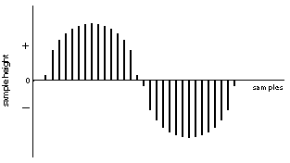

***Figure 2-2. Sampled Waveform***

Each vertical bar in Figure 2-2 represents a single sample. The height of a bar indicates the value of that sample.

The mechanism that converts an audio signal into digital samples is called an *analog-to-digital converter*, or *ADC*. To convert a digital signal back to analog, you need a *digital-to-analog converter*, or *DAC* (pronounced "dack").

**Sampling Rate**

The rate at which a waveform is sampled is called the *sampling rate*. Like frequencies, sampling rates are measured in hertz. The CD standard sampling rate of 44,100 Hz means that the waveform is sampled 44,100 times per second. This may seem a bit excessive, considering that we can't hear frequencies above 20 kHz; however, the highest frequency that a digitally sampled signal can represent is equal to half the sampling rate. So, a sampling rate of 44,100 Hz can only represent frequencies up to 22,050 Hz, a boundary much closer to that of human hearing.

**Quantization**

Just as a waveform is sampled at discrete times, the value of the sample is also discrete. The *quantization* of a sample value depends on the number of bits used in measuring the height of the waveform. An 8-bit quantization yields 256 possible values; 16-bit CD-quality quantization results in over 65000 values. As an extreme example, Figure 2-3 shows the waveform used in the previous example sampled with a 3-bit quantization. This results in only eight possible values: .75, .5, .25, 0, -.25, -.5, -.75, and -1.

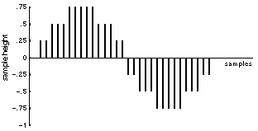

***Figure 2-3. Three-Bit Quantization***

As you can see, the shape of the waveform becomes less discernible with a coarser quantization. The coarser the quantization, the "buzzier" the sound.

**Storing Sampled Data**

An increased sampling rate and refined quantization improves the fidelity of a digitally sampled waveform; however, the sound will also take up more storage space. Five seconds of sound sampled at 44.1 kHz with a 16-bit quantization uses more than 400,000 bytes of storage―a minute will consume more than five megabytes. Several data compression schemes have been devised to decrease storage while sacrificing some fidelity.

Wikipedia also has a [decent primer](https://en.wikipedia.org/wiki/Digital_audio) on computer audio for the curious.